**Digital Handheld Ultrasonic Flow Meter**

**PORTABLE TYPE – FIXED TYPE OPTIONS**

|  |  |
| --- | --- |
| http://i.ebayimg.com/images/g/9TEAAOxyOeBRzTtU/s-l1600.jpg | http://www.tuf-2000.com/english/uploadfile/image/20150908/20150908140104_22190.jpg |
|  | E:\R & S 9-17\LITTERATURE\HYDROLOGY\Water Flow Meter\imagery\mn2.jpg |
| E:\R & S 9-17\LITTERATURE\HYDROLOGY\Water Flow Meter\imagery\belt 3.JPG | E:\R & S 9-17\LITTERATURE\HYDROLOGY\Water Flow Meter\imagery\rBVaWVw0RgqAR-o7AAGI7tWi0_4528.jpg |

**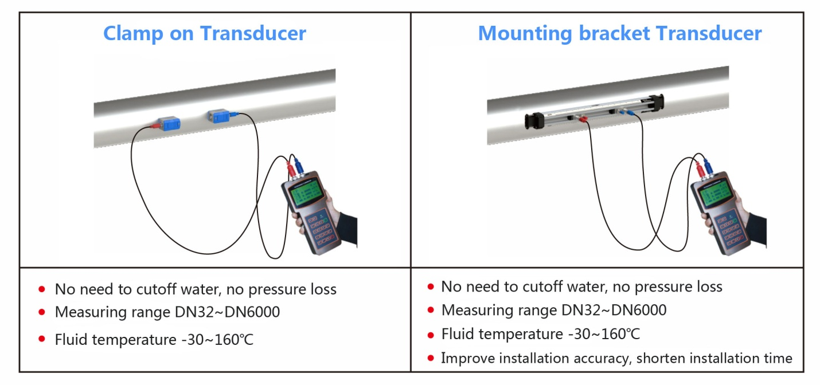**

**Measuring pipe size from DN50mm to DN700mm ( 2 inch to 27 inch approx.), Optional Transducers : Available for large pipe diameters DN50mm to DN6000mm**

**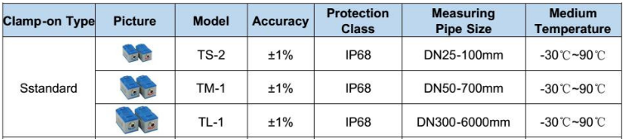**

**APPLICATIONS:**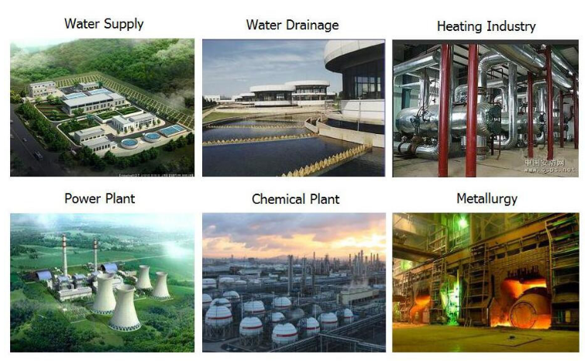

|  |  |
| --- | --- |
| S  E:\R & S 9-17\LITTERATURE\HYDROLOGY\Water Flow Meter\imagery\inl.png | M  E:\R & S 9-17\LITTERATURE\HYDROLOGY\Water Flow Meter\imagery\inst.png |
| Q  E:\R & S 9-17\LITTERATURE\HYDROLOGY\Water Flow Meter\imagery\HTB1d5_gOXXXXXaKapXXq6xXFXXXV.jpg | E:\R & S 9-17\LITTERATURE\HYDROLOGY\Water Flow Meter\imagery\mm.JPG  **C:\Users\ABDUL REHMAN\Desktop\n1.JPG** |