***2- Flow Probe / Flow Meter for Streams/Rivers***

The Flow Probe is a water velocity instrument for measuring flows in open channels and partially filled pipes.  The water velocity probe consists of a protected water turbo prop positive displacement sensor coupled with an expandable probe handle ending in a digital readout display.  The water flow meter incorporates true velocity averaging for the most accurate flow measurements.  The Flow Probe is ideal for storm water runoff studies, sewer flow measurements, measuring flows in rivers and streams, and monitoring water velocity in ditches and canals.

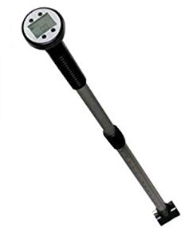 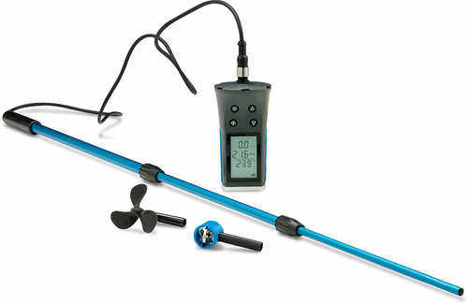

*** ***

The *Advanced Stream Flow Meter* connects to the same sturdy impeller stick as the **standard flow meter** but boasts a much more sophisticated meter which does away with the need for conversion charts. The new meter displays velocity in units of meters per second or mph. (Know us your Application, We ‘ll Recommend you Best Suitable Model)