4-NON Contact Open Channel Flow meter for Water Channel:

It consists of two elements, a host, which has display and an integral keypad for programming, and a transducer, which must be mounted directly above the surface to be measured. It can be widely applied to the environmental protection, water treatment, irrigation, chemical, and other industries.
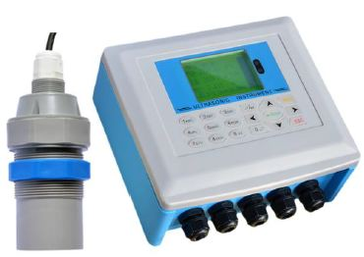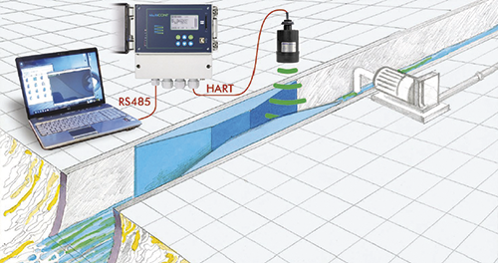
Application:

- Right-angle rectangular weir,

- Triangular weir,

- Width weir,

- Parshall flume

