# Solar Radiation (Silicon Pyranometer) Smart Sensor

### Overview

Effectively measure light levels with this silicon pyranometer sensor. The Solar Radiation Smart Sensor enables rapid deployment. Since HOBO data loggers recognize this sensor, no complicated programming or setup is required. This product offers a measurement range of 0 to 1280 W/m2 over a spectral range of 300 to 1100 nm. A measurement averaging mode is available.

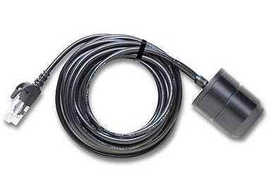

### Highlighted Features

* Measurement range of 0 to 1280 W/m2 over a spectral range of 300 to 1100 nm
* Plug-n-play smart sensor

***Specifications:***

**Measurement range:** 0 to 1280 W/m2  
**Operating temperature range:**-40° to 75°C (-40° to 167°F)  
**Accuracy:** ±10 W/m2 or ±5%, whichever is greater in sunlight. Additional temperature induced error ±0.38 W/m2 /°C from 25°C (0.21 W/m2/°F from 77°F)  
**Resolution:** 1.25 W/m2  
**Drift:**<±2% per year  
**Spectral range:** 300 to 1100 nm

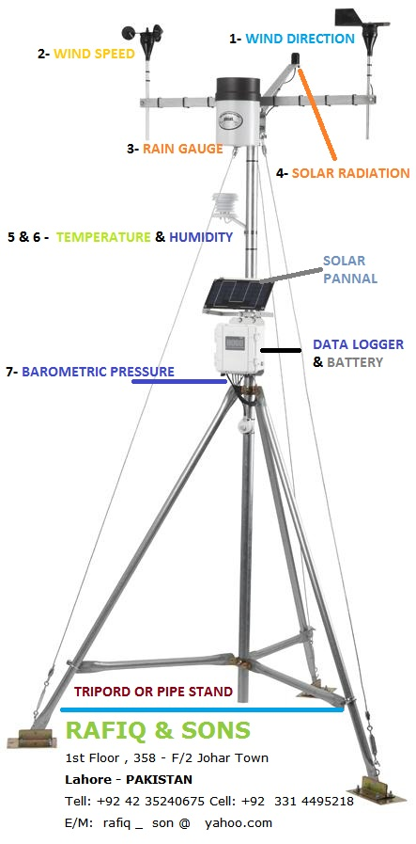

A View has been changed due to Combine wind speed and Direction sensor.