# Wind Speed and Direction Smart Sensor (combine)

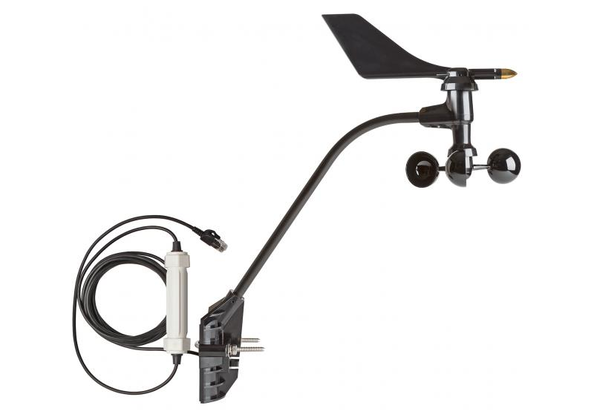

Wind Speed/Direction Smart Sensors are compatible with weather station loggers. The sensors feature a plug-in modular connector for easy installation, and all configuration parameters are stored in the sensor and automatically communicated to the logger, eliminating the need for programming or extensive setup. It is designed to meet World Meteorological Organization (WMO) guidelines

|  |  |
| --- | --- |
|  | **Wind Speed Wind Direction** |
| **Measurement Range** | 0 to 76 m/sec (0 to 170 mph) | 0 to 355 degrees |
| **Accuracy** | ±1.1 m/sec (±2 mph) or ±5% of reading, whichever is greater | ±7 degrees |
| **Resolution** | 0.5 m/sec (1.1 mph) | 1 degrees (0 to 355 degrees) |
| **Starting Threshold** | ≤1 m/sec (2.2 mph) | 1 m/sec (2.2 mph) |

# Rain Gauge Smart Sensor

The Rain Gauge Smart Sensors features the new AeroCone® design, for better measurement accuracy in high-wind conditions. This gauge is made from UV-stabilized ABS plastic to provide a cost-effective sensor for rainfall measurement, and is plug-and-play compatible with all HOBO weather stations.

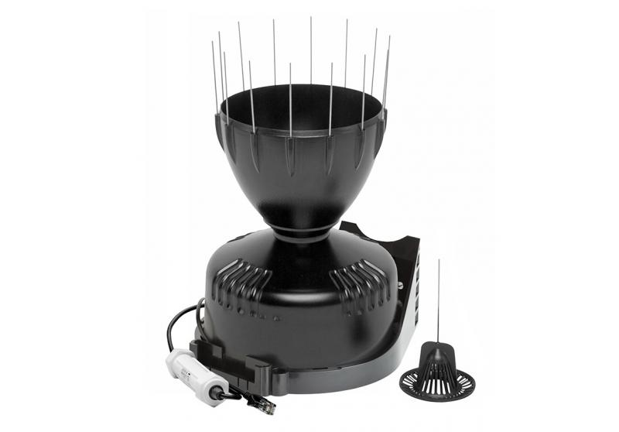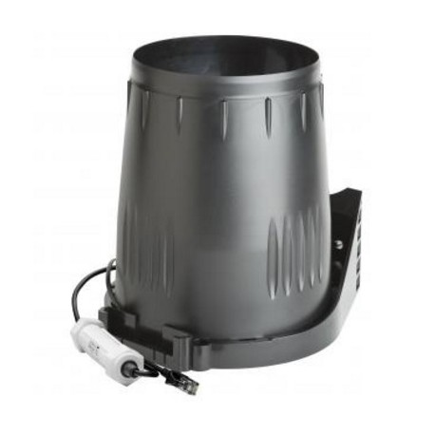

### Highlighted Features

* Streamlined design reduces the amount of missed rain capture in windy conditions, resulting in more accurate rainfall data
* Improved debris screen locks in place to ensure it remains in place during high winds
* 16.5 cm (6.5”) collector opening meets World Meteorological Organization (WMO) guidelines

***Specifications:***

|  |  |
| --- | --- |
| **Measurement Range** | 0 to 10.2 cm (0 to 4 in.) per hour, maximum 4,000 tips per logging interval |
| **Accuracy** | ±4.0%, ±1 rainfall count between 0.2 and 50.0 mm (0.01 and 2.0 in.) per hour; ±5.0%, ±1 rainfall count between 50.0 and 100.0 mm (2.0 and 4.0 in.) per hour |
| **Resolution** | 0.01 in. (S-RGC-M002) or 0.2 mm (S-RGF-M002) |
| **Calibration** | Requires annual calibration; can be field calibrated |
| **Operating Temperature Range** | 0° to 50°C (32° to 122°F), survival -40° to 75°C (-40° to 167°F) |
| **Environmental Rating** | Weatherproof |
| **Housing** | UV-stabilized ABS plastic |
| **Mechanism** | Tipping bucket with magnetic reed switch pivots on metal shaft |
| **Dimensions** | 16.5 cm opening diameter (6.5 in.) x 24 cm (9.5 in.) high; 214 cm2 (33.2 in.2) collection area |
| **Weight** | 1.2 kg (2.7 lbs) |
| **Bits per Sample** | 12 |
| **Number of Data Channels\*** | 1 |